Note about 'extended' Voce-law
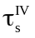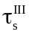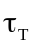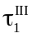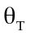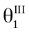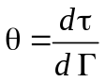
Stage III
Stage IV

Figure 1: Schematic of a work hardening curve indicating the parameters used in such a way that a tensile curve could be reproduced by a simulation using this hardening law in a Taylor model.
Sufficient set of parameters:
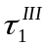, 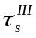, 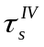, 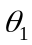, 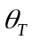

All other quantities can be calculated from these (using simple algebra). Representations of experimental work hardening curves in the form of θ - τ plots are readily found in physical metallurgical literature. Note that

τ = σ/M

Γ=Mε

in which M is the average Taylor factor of the materials. It depends on the texture. For tensile tests, people who do not desire to measure the texture and calculate M from it, use a guess for the value of M, namely 3.06 (fcc metals) or 2.78 (bcc metals), for a uniaxial tensile test. This leads to a composite curve constructed with two linear θ - τ expressions (cross-over point at -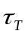) which can be integrated to get a τ− Γ expression which on its turn can be converted into a σ-ε expression.
Experimental θ - τ plots can often (with a little bit of goodwill) be schematized as
fig. 1 shows, after which , , , , can be obtained from the schematic curve.

Fig. 2.44 in Progr. Mater. Sci. 25 (1980) p. 119, shows curves for 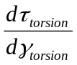 as a function of 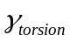, non-converted results of a torsion test on a low carbon steel bar. Using M=1.5 as the Taylor factor for steel in torsion, this leads to:

=222 MPa

=120 MPa

=200 MPa

=44 MPa

